TAXES MADE SIMPLE
An Easy Note on Types of Taxes (Chapter 10: Classification and Choice of Taxes)
Every government needs money to run the country — build roads, pay salaries, run schools and hospitals. This money mostly comes from taxes. But not all taxes are the same. Economists have divided taxes into different types based on different things — like who really pays them, how the rate changes with income, and how they are measured. This note explains all these types in simple words, with easy examples.
There are 5 main ways to classify (group) taxes:
- Direct and Indirect Taxes
- Proportional, Progressive, Regressive and Degressive Taxes
- Specific and Ad Valorem Taxes
- Single and Multiple Taxes
- Value Added Tax (VAT) — covered in a separate chapter

1. Direct Tax vs Indirect Tax
This is the most common way to divide taxes. The key question is: can the person who pays the tax pass its burden on to someone else, or does he have to bear it himself?

What is a Direct Tax?
A direct tax is a tax that is paid by the same person on whom it is placed. He cannot shift (pass on) the burden to anyone else. The person who pays it to the government is also the person who actually feels the pinch of it.
Example: Income tax. If your income is taxed, you pay it yourself. You cannot make your neighbour pay your income tax for you.

What is an Indirect Tax?
An indirect tax is first paid by one person, but its burden is later passed on (shifted) to another person. So the person who pays it to the government and the person who actually bears its cost are two different people.
Example: Sales tax or excise duty on cloth. The cloth factory pays the tax to the government, but it adds this tax to the price of the cloth. So, in the end, it is the customer who actually bears the cost when he buys the cloth at a higher price.

How Different Economists Explained Direct and Indirect Tax
Different thinkers looked at this same idea from different angles. Here is what each of them said, in simple words:
- John Stuart Mill: A direct tax is demanded from the very person who is meant to pay it. An indirect tax is demanded from one person, but he expects and intends to recover it from someone else. In short — direct tax cannot be passed on, indirect tax is meant to be passed on.
- Philip Taylor: The real difference between direct and indirect tax is 'shiftability' — that is, whether the burden can be shifted to someone else or not. Direct taxes cannot be shifted; indirect taxes can be shifted.
- A.R. Prest: The difference should be based on what the tax is charged on. If a tax is charged on income received, it is direct (like income tax or capital gains tax). If a tax is charged on money spent, it is indirect (like customs duty or excise tax, which are based on expenditure).
- Antonio De Viti De Marco: Direct taxes hit a citizen's income at the moment it is produced or earned (like tax on land income, business income, or total individual income). Indirect taxes hit a citizen's income at the moment it is spent — that is, when he uses his money to buy goods or transfer property.
- Based on how it is collected: Some experts simply look at the collection method. A tax is called direct if it is collected regularly from a fixed list of named taxpayers. A tax is called indirect if it is collected only when a certain act happens (like a purchase), with no fixed list of names and no fixed time interval.
In short: no single definition is perfect, and a tax can behave like a direct tax at one time and an indirect tax at another. But the most scientific and widely accepted way to tell them apart is still the shifting of burden — can the person pass the cost to someone else or not?

Impact and Incidence (two simple words to remember)
- Impact = the first burden. It falls on the person who pays the tax to the government first.
- Incidence = the final burden. It falls on the person who actually ends up bearing the cost.
In a direct tax, impact and incidence fall on the same person. In an indirect tax, impact and incidence fall on different persons.

Merits (Advantages) of Direct Taxes
- Creates awareness: Since people feel the pinch directly, they become alert about how the government spends their money.
- Cheap to collect: The government collects it at the source, so the collection cost is low.
- Fair: The rate can be set according to a person's ability to pay, so rich people can be made to pay more.
- Reduces the gap between rich and poor: The government can use it to lower income and wealth inequality.
- Certain: Both the taxpayer and the government know in advance how much tax will be paid.
- Flexible: The government can quickly raise more money by simply increasing the tax rate during a crisis.

Demerits (Disadvantages) of Direct Taxes
- Hard to fix the right amount: It is difficult to decide exactly how much tax is fair for each income level.
- Inconvenient: Taxpayers must keep detailed accounts and fill many complicated forms.
- Costly for small taxpayers: When there are many taxpayers each paying a small amount, collecting from all of them can be expensive.
- Easy to evade: People can hide their real income and avoid paying the full tax.
- Unpopular: Because people feel the burden directly, they dislike paying it.
- Falls mainly on the rich: Poorer people are usually excluded, so it does not spread the burden across everyone.

Merits (Advantages) of Indirect Taxes
- Convenient: People pay it in small amounts while buying things, so it does not feel heavy. Sometimes they don't even notice they are paying tax.
- Cannot be evaded: Since it is hidden in the price of goods, nobody can escape it while buying that good.
- Productive and flexible: If placed on daily-use items like sugar, oil, or cigarettes (things people buy anyway), it brings in steady and growing revenue.
- Improves welfare: A high tax on harmful items like alcohol reduces their use, which is good for society.
- Fair in one sense: Everyone who buys the good pays it, rich or poor.
- Guides the economy: The government can encourage important industries and discourage harmful ones by taxing goods differently.

Demerits (Disadvantages) of Indirect Taxes
- Unfair to the poor: Rich and poor pay the same tax amount on the same good, so poor people feel a bigger pinch relative to their income. This is called regressive.
- Costly to collect: Traders often raise prices by more than the actual tax amount.
- Uncertain revenue: Once a good is taxed, its price rises and people may buy less of it, so the government cannot be sure how much money it will collect.
- No civic awareness: Since the tax is hidden in the price, people don't feel it directly and don't question the government's spending.
- Fuels inflation: These taxes raise prices without reducing people's spending power, so prices, costs, and wages keep rising in a cycle.

Direct vs Indirect: Which one is better?
Economist Gladstone once said direct and indirect taxes are like two attractive sisters — he liked both equally! But some economists like Ursula Hicks argued that a direct tax causes less pain (sacrifice) to people than an indirect tax that collects the same amount of money. This can be shown using a diagram with 'indifference curves' (curves that show a consumer's satisfaction level).
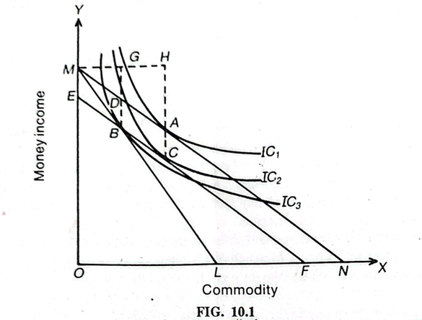
In simple words: if the government collects the same amount of money either through a direct tax (like income tax) or an indirect tax (like excise duty), the person ends up happier (better off) under the direct tax. This is why many economists say direct taxes are slightly better for people's welfare. However, Milton Friedman disagreed, saying this idea only looks at one person and ignores the whole economy.

Direct and Indirect Taxes Work Together
In real life, no government relies on only one type of tax. Both types are needed and they support each other:
- Indirect taxes are better when direct taxes become too heavy and people start resisting them.
- Direct taxes are better for reducing inequality, since indirect taxes cannot be fine-tuned for rich and poor separately.
So, a good tax system uses a mix of both — this is called complementarity. Gladstone (as Britain's Finance Minister) said it was his duty to pay attention to both kinds of taxes.

2. Proportional, Progressive, Regressive and Degressive Taxes
This classification is based on one simple question: as a person's income goes up, does the tax rate (the percentage they pay) stay the same, go up, or go down?

Proportional Tax
In a proportional tax, everyone pays the same percentage of tax, no matter how much they earn. The rate stays fixed.
Example: If the tax rate is fixed at 10%, a person earning Rs. 100 pays Rs. 10, and a person earning Rs. 1,00,000 pays Rs. 10,000. The rate (10%) never changes.
Income (Rs.) | Tax Rate (%) | Tax Amount (Rs.) | Income after Tax (Rs.)
100 | 10 | 10 | 90
1000 | 10 | 100 | 900
10000 | 10 | 1000 | 9000
1,00,000 | 10 | 10,000 | 90,000

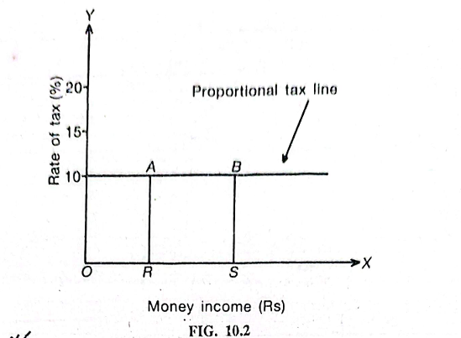
[INSERT IMAGE HERE: Figure 10.2 — Proportional tax line graph (flat horizontal line showing rate of tax stays at 10% as money income rises)]
- Key point: The rate never changes with income.
- Key point: It is simple — easy for anyone to calculate their own tax.
- Key point: The gap between rich and poor stays exactly the same after tax, since everyone loses the same percentage.
Good things about it: It is very easy to understand and calculate. It does not disturb the existing income structure of society.
Problems with it: Since the value of extra money matters less to a rich person than a poor person, taxing both at the same rate feels heavier for the poor. It also does not reduce the income gap between rich and poor.

Progressive Tax
In a progressive tax, the tax rate increases as income increases. People with higher income pay a bigger percentage of their income, and people with lower income pay a smaller percentage. Income below a certain limit may even be tax-free.
Example: A person earning Rs. 1,000 might pay tax at 10%, while a person earning Rs. 4,000 pays at 25%. The more you earn, the higher the rate you pay — not just a higher amount, but a higher percentage.
Income Group (Rs.) | Tax Rate (%) | Tax Amount (Rs.) | Income after Tax (Rs.)
0 - 1,000 | 10 | 100 | 900
1,001 - 2,000 | 15 | 300 | 1700
2,001 - 3,000 | 20 | 600 | 2400
3,001 - 4,000 | 25 | 1000 | 3000

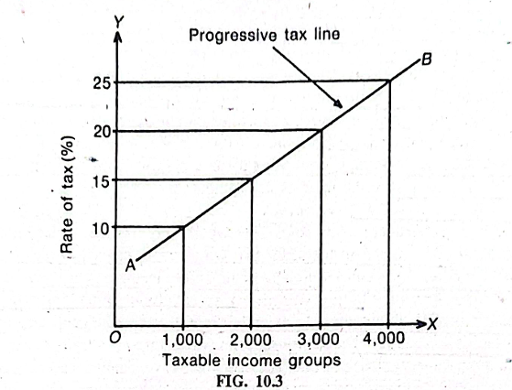
[: Figure 10.3 — Progressive tax line graph (rising line showing tax rate increasing from 10% to 25% as taxable income group increases)]
- Key point: Higher income = higher tax rate (not just higher tax amount).
- Key point: Usually there is an exemption limit — very low incomes may pay no tax at all.
- Key point: Also called a 'graduated tax' because income is divided into slabs (steps), and each slab has its own rate.
Good things about it (advantages):
- Based on ability to pay: Rich people can afford to pay more, so the rate rises with income. It matches the idea that people with more money should contribute more.
- Reduces inequality: It makes the gap between rich and poor smaller, since the rich are taxed at higher rates.
- Productive: The government can raise a large amount of extra money just by increasing the rates, which is very useful during a financial crisis.
- Economical: It brings in a big rise in government income without much extra cost of collection.
- Elastic: Even small changes in the tax rates can bring big changes in the government's income.
- Supports social justice: It spreads the sacrifice more fairly across society, taxing people according to what they can actually afford.
Big thinkers like Alfred Marshall, Pigou and John Maynard Keynes all supported progressive taxation.
Problems with it (disadvantages):
- Hard to measure: It is hard to measure exactly how much 'satisfaction' or 'value' money gives to different people, so deciding the exact rates is tricky.
- Ignores the 'benefit received' idea: Some economists argue that tax should be linked to how much benefit a person gets from government services — and by that logic, poorer people (who use more welfare services) should pay more, which progressive tax does not do.
- May reduce saving: It can discourage saving among the rich, since they lose more of their extra income to tax, which can hurt capital formation (investment) in the country.
- Scope for evasion: People try harder to hide income or find loopholes to avoid paying high rates.

Regressive Tax
A regressive tax is the exact opposite of progressive tax. Here, as a person's income increases, the percentage of tax they pay actually goes down. So the poor end up paying a bigger share of their income than the rich.
Example: Notice in the table below: as income rises from Rs. 1,000 to Rs. 4,000, the tax rate falls from 15% down to 6%.
Income (Rs.) | Tax Rate (%) | Tax Amount (Rs.) | Income after Tax (Rs.)
1000 | 15 | 150 | 850
2000 | 10 | 200 | 1800
3000 | 7 | 210 | 2790
4000 | 6 | 240 | 3760

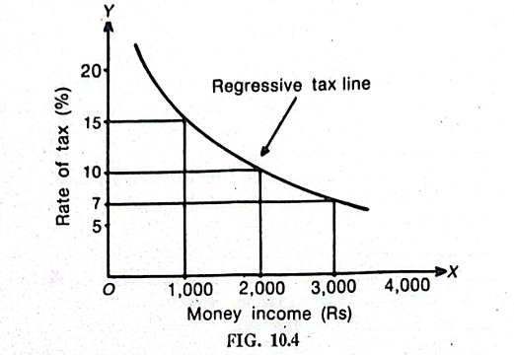
[Figure 10.4 — Regressive tax line graph (falling curve showing tax rate dropping from 15% down to below 7% as money income rises)]
- Key point: The rate falls as income rises — unfair to poorer people.
- Key point: This system has been dropped almost everywhere because it is unjust.
Example: The old British salt tax in India (before 1947) was a regressive tax — it hit poor people harder, which is why Mahatma Gandhi protested against it in the famous Dandi March.

Degressive Tax
A degressive tax is a mild (soft) form of progressive tax. The rate keeps rising with income, but only up to a certain point. After that point, it becomes a fixed flat rate for all higher incomes. So it is a mix of progressive tax (at lower incomes) and proportional tax (at higher incomes).
Example: Tax rate rises from 5% to 20% as income goes up to Rs. 50,000. But after Rs. 50,000, every extra rupee is taxed at the same flat 20%, no matter how high the income goes.
- Key point: Rich people end up making a smaller sacrifice compared to a fully progressive tax.
Overall, among all four, progressive tax is considered the best and fairest system. Most developed countries, and India too, mainly follow the progressive system for income tax.

3. Specific Tax and Ad Valorem Tax
This classification applies to taxes on goods (commodities). The question here is: how is the tax amount decided — by the physical unit of the good, or by its price?

Specific Tax
A specific tax is charged based on the physical quantity of a good — its weight, size, or measurement. It does not matter how expensive or cheap the good is.
Example: A tax of Rs. 2 per kilogram of sugar, no matter whether the sugar is a cheap or an expensive brand.
- Good thing: Easy to charge and collect, since you just measure the weight or size.
- Problem: It hits poor people harder, because a flat amount per kg is a bigger share of a poor person's money than a rich person's.

Ad Valorem Tax
An ad valorem tax is charged based on the value (price) of the good, not its weight or size. 'Ad valorem' simply means 'according to value'.
Example: A 5% import duty on a car — an expensive car pays more tax in rupees than a cheap car, because the tax is a percentage of the price.
- Good thing: Fairer, since expensive goods (usually bought by richer people) pay more tax.
- Problem: It is hard to know the real value of a good. Traders sometimes lie about the value in their bills to pay less tax.
In practice, a good tax system uses both specific and ad valorem taxes, choosing whichever fits a particular good better.

4. Single Tax and Multiple Taxes
This classification is about how many different taxes a government uses to collect its total revenue.

Single Tax
A single tax system means the government collects all its money from just one single tax, instead of many different taxes.
Long ago, a group of economists called the Physiocrats (18th century France) supported this idea. They believed land gives a 'surplus' (extra value) to landlords, so all tax should be collected only from land rent. Later, in the 19th century, a thinker named Henry George also supported a single tax on land.
Problems with a single tax on land rent:
- It would not produce enough revenue for the government's needs.
- It gives a very unfair spread of burden: a rich person who owns no land would pay no tax at all, while a poor person who owns a small piece of land would be forced to pay a proportionately very high tax.

Can a Single Tax on Income Work Instead?
Some thinkers asked: what if the one single tax was placed on income instead of land? A single tax on income could actually be designed well — it could bring in a fair amount of revenue and avoid unfairness by using slabs and different rates for different income groups. But even this idea has three serious problems:
- Difficult and costly to collect: It would be hard and expensive to collect this tax, especially from people with small incomes.
- No special contribution from inherited wealth: A single income tax would not be able to get any extra contribution from people who simply inherit wealth (get it from family) rather than earn it.
- Hurts savings: It would discourage saving more than a mix of different taxes would.
Because of these problems, no modern country actually uses a true single tax system today.

Multiple Tax
A multiple tax system means the government collects money using many different taxes on many different things — income tax, sales tax, property tax, and so on, all at once. This is the system used almost everywhere in the world today.
- It helps stop large-scale tax evasion, since people cannot escape every tax at once.
- It can be designed to reduce income inequality more effectively.
- Weaknesses of one tax can be balanced out by the strengths of another tax.
- It brings in more total revenue for the government.
- It is more flexible than depending on just one tax.
However, having too many small taxes is also not good — collecting lots of tiny taxes costs a lot of money. So the best approach is to rely on a few major taxes: income tax and inheritance tax mainly on the rich, and indirect taxes on a few common goods (avoiding taxes on things poor people need for basic health) to also collect from the poor fairly.

Quick Summary Table
Type of Tax | Simple Meaning | Example
Direct Tax | Paid and borne by the same person | Income tax
Indirect Tax | Paid by one, burden shifted to another | Sales tax, excise duty
Proportional Tax | Same rate for all incomes | Flat 10% income tax
Progressive Tax | Rate rises as income rises | Slab-based income tax
Regressive Tax | Rate falls as income rises | Old salt tax
Degressive Tax | Rate rises, then becomes flat | Mixed rate income tax
Specific Tax | Based on weight/size/measure | Tax per kg of sugar
Ad Valorem Tax | Based on value/price | 5% import duty
Single Tax | Only one tax for all revenue | Tax only on land rent
Multiple Tax | Many taxes together | Income tax + sales tax + more

That's it! Once you remember the simple question behind each pair (who bears the burden, how does the rate change, how is the tax measured, and how many taxes are used), the whole chapter becomes very easy to recall.

